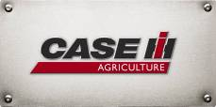
Case IH Agriculture Equipment, Inc.

For More Information, contact:
Scott Rasch 262/636-6615
scott.rasch@cnh.com
or
Ryann Greve 262/636-5921
ryann.greve@cnh.com

Press Materials

CASE IH LAUNCHES FIELD OF DEALS SWEEPSTAKES

RACINE, Wis. (February 1, 2012)
As part of its Field of Deals sales event, Case IH is sponsoring a sweepstakes where one lucky grand prize winner will receive a 2012 Ram truck, plus free fuel for one year. Case IH customers and prospects are encouraged to visit their local Case IH dealer and enter for a chance to win.
“Our Field of Deals sales event provides great offers on our full line of Farmall®, Puma® and Maxxum® tractors, as well as balers and windrowers,” says Kyle Russell,
Senior Director of Marketing, Case IH North America. “While checking out the latest equipment at your local Case IH dealer, you also can enter to win a new Ram truck and other prizes.”
Through April 30, U.S. and Canadian Case IH customers can take advantage of many Field of Deals offers and sign up for the sweepstakes.
“Case IH has rolled out a lot of new tractors in the past 12 months,” Russell adds. “Now is a great time to visit your local Case IH dealer and see first-hand our tractors and hay tools designed with the power, efficiency and versatility to provide operators with more comfort and productivity.”
For more information on the Case IH Field of Deals sales event and sweepstakes, including official rules, visit your local Case IH dealer or www.caseihdeals.com.
(more)

Case IH is a global leader in agricultural equipment, committed to collaborating with its customers to develop the most powerful, productive, reliable equipment – designed to meet today’s agricultural challenges. Challenges like feeding an expanding global population on less land, meeting ever-changing government regulations and managing input costs. With headquarters in the United States, Case IH has a network of dealers and distributors that operates in over 160 countries. Case IH provides agricultural equipment systems, flexible financial service offerings and parts and service support for professional farmers and commercial operators through a dedicated network of professional dealers and distributors. Productivity enhancing products include tractors; combines and harvesters; hay and forage equipment; tillage tools; planting and seeding systems; sprayers and applicators; site-specific farming tools and utility vehicles. Case IH is a brand of CNH (NYSE: CNH), a majority-owned subsidiary of Fiat Industrial S.p.A. (FI.MI).
###
For more information, visit www.caseih.com.

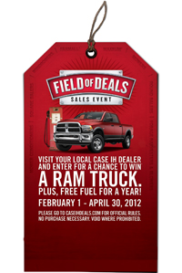
Photo caption:
The Case IH Field of Deals sales event runs from February 1 through April 30. Visit your local Case IH dealer to sign up for a chance to win a 2012 Ram truck plus free fuel for a year.

